Chapter 6, Problem 24.

Assume that all the capacitors were initially uncharged and that the 90 volt source starts at zero and gradually increases to 90 volts. What are the final voltages across each capacitor and the energy stored in each capacitor.

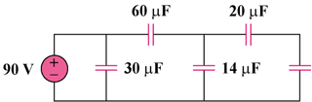
80 µF

Figure 6.58
For Prob. 6.24.

